Game Design Document

Fill up the Following document

1. Write the title of your project.

Maze Runner

1. What is the goal of the game?

Get all food items and escape from the maze

1. Write a brief story of your game?

A kid entered a cave and got lost. He is hungry. He finds food items hidden in the cave and then proceeds to finding the exit and escape

1. Which are the playing characters of this game?

* Playing characters are the ones which respond to the user based on the input from the user
* Cars, monkeys, dinos, wizards etc, are the playing characters in the game.

|  |  |  |
| --- | --- | --- |
| Number | Character Name | What can this character do? |
| 1 | kid | Move around and eat food and also has to escape |
| 2 |  |  |
| 3 |  |  |
| 4 |  |  |
| 5 |  |  |
| 6 |  |  |
| 7 |  |  |
| 8 |  |  |

1. Which are the Non Playing Characters of this game?

* Non Playing characters are the ones which don't have an action or a behaviour when the user interacts with the game.
* Hurdles, stones, bananas, coins, etc are non playing characters in the game.

|  |  |  |
| --- | --- | --- |
| Number | Character Name | What can this character do? |
| 1 | Food items | Has to be eaten and give points |
| 2 |  |  |
| 3 |  |  |
| 4 |  |  |
| 5 |  |  |
| 6 |  |  |
| 7 |  |  |
| 8 |  |  |

Draw your imagination of this game. What does this game look like?

* Draw the game either on your computer or on paper,
* Add images of scenes of the game to show each of the playing and non-playing characters at least once.

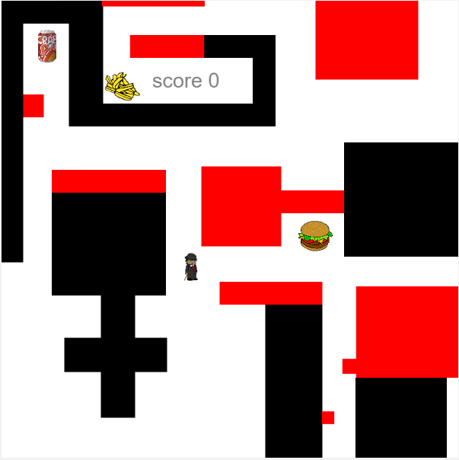

How do you plan to make your game engaging?

Yes ofcourse.